


Name of Beneficiary | Father /Husband Name | CNIC | Contact | UC | District
Basheeran Khatoon | Rahim Bux | 45402-1060515-6 | 0300-7060759 | 60 Mile UC Talka Daur | S.B.A

Sindh Irrigated Agriculture productivity Enhancement project (SIAPEP)
Growing their own vegetables with assistance from the world bank Support for the Recovery of small Kitchen Gardening Based Livelihoods of Vulnerable Farmers of Sindh Provinces
Basheran Khaton is the one of the beneficiary of SIAPEP Kitchen Gardening project funded by World bank implemented by Shah Sachal Sami Foundation
Basheran khatoon is the residential of village Ghouse Bux Rind UC 60 Mile,Baheran depened on daily wages income her husband is farmer and deepened on daily wages income.
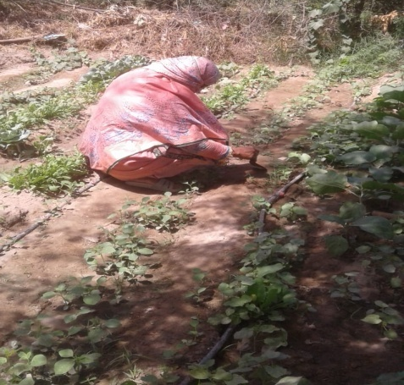
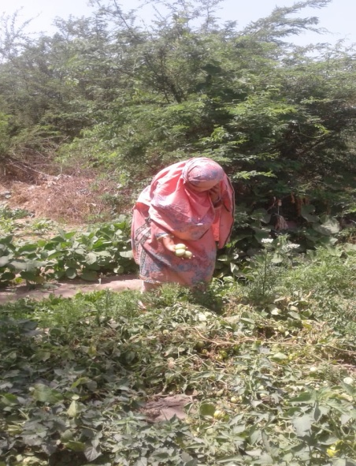
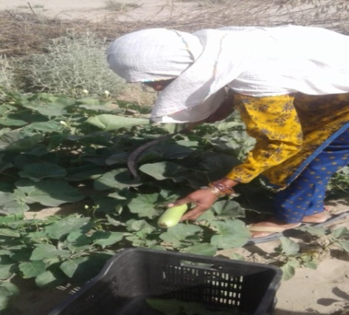
Vegetables helped her to fight poverty. She able to buy new cloths for her children,one of the beneficiaries of the SIAPEP kitchen gardening project in Village,Ghouse Bux rind uc 60 Mile Talka Daur District Shaheed Benazirabad.I even gave gifts to my neighbors and relatives something that I could never afford before,”she expressed her views.Basheran khaton belongs to a group of 25 women which practiced kitchen gardening together with support and guidance from SIAPEP,Basheran and her husband Rahim Bux have three children, all less than 10 years of age. Rahim Bux has been earning income for his young family by growing wheat on a rented 1-acre plot of land.No matter how hard I tried, there was never enough money to make ends meet The 2022 floods dealt yet another blow on the already struggling family.Their village was flooded, and like many of their neighbors,Basheran Khaton family lost their house,standing crops and livestock. Rahim Bux and Basheran Khaton were desolate.
Luckily for the family, Basheran was among the 200 women to whom SIAPEP offered support through a small kitchen gardening activity. Even though target households were mostly dependent on agriculture for their livelihoods, none of them had vegetable gardens before. A kitchen garden can supply up to half of all non-staple food needs and a significant share of vitamins and minerals for the household and is an important tool to enhance food security in vulnerable communities.This effort was part of the SHAH SACHALSAMI FUNDATION and SIAPEP Support for the recovery of agriculture based livelihoods of vulnerable farmers,Together with the support of World Bank,SIAPEP,SSSF explained to the participating women about the different approaches to kitchen gardening available to them, and offered to provide the seeds, fertilizer,and advice, training sessions throughout the process.While in all Taluka of district Shaheed benazirabad , villagers prefer to develop individual kitchen gardens plan for next sessions beneficiaries residents of Village Ghouse bux Rind decided to work collectively. A group of 25 women was formed, and SSSF helped them at every stage from land preparation to post harvesting to seed preservation and marketing skills to support the initiative,Each of the beneficiary’s women received a package of 3 session’s vegetable seeds and fertilizer sufficient for 20 by 20 Sqr fetes plot, tool kits drip kits. SSSF also taught Basheran Khatoon i and her neighbors how to prepare soil, how to plant the seeds for best yields, and a variety of other techniques for vegetable husbandry.It is simple,practical and interesting to grow and sell vegetables but I never knew it,” said Basheeran Khatoon .“Next year,I will use the skills and methods learned through the project in my own garden.Within one month, vegetables Brinjal(bengan) fruit.First,tomatoes and Bottle Gourd(loki)Bitter Gourd(karela)Lufa(sindhi tori) were ready to harvest, then okra.In her garden, Basheeran Khatoon produced enough vegetables for her family to use for more than three months,This amount of vegetables saved the family approximately 8000 Rupees worth of food. Additionally, put onion in storage for future use. Her children liked fresh vegetables, while Basheran enjoyed working side by side with her neighbors, plucking vegetables and cooking her own produc.In addition to growing food for their families, for almost two months, the 25 women sold a pickup-van-(Mazda )full of tomatoes and okra every other day. While the community incurred 3,000 Rupees in cost for the van rental and associated expenses, each pickup carried 110 bags of vegetables which sold for approximately 14,300 Rupees By the end of the season, each participating household – including Basheran Khatoon’s family, earned around 10,000 Rupees.Basheeran also plans to continue growing vegetables in her backyard, even when SIAPEP support ends. Basheeran said that “Kitchen garden provides a food safety net for the family, and it’s fun to cultivate, sell and store the vegetables which I grew with my own two hands,”Together with her husband, Basheeran plans to increase the area of land use for growing vegetables next year and invest in good seed and fertilizer.
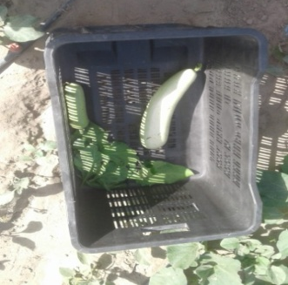
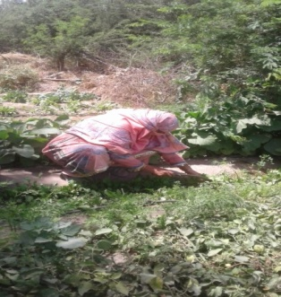
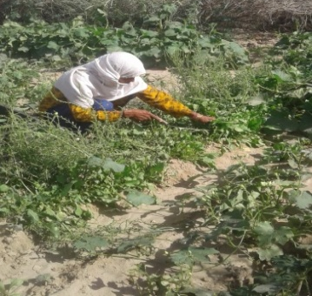
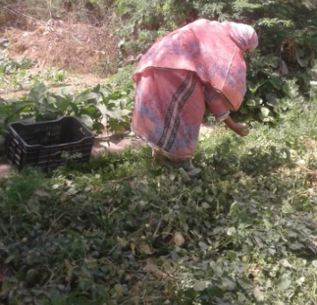
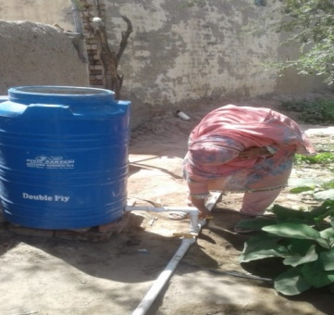
She hopes that one day her vegetable garden will help the family have the better future she has always been dreaming about..

